**COSC363 Assignment 1: A Robot’s World**

**Description**

The Scene portraits a flying robot (flybot) generating a land robot (landbot) on an isolated piece of land in space. As the flybot circles the land and its spotlight hits the hedges (on the far side), the hedges start to grow. The hedges are cut in half when the landbot comes close enough to trim the hedges. There are also potted plants in the scene which continuously sways unless it senses that the landbot near the potted plants. If the landbot is near the potted plants the colour of the flower will start to change and stay that way until the landbot is not near the potted plants anymore.

**Objects in detail**

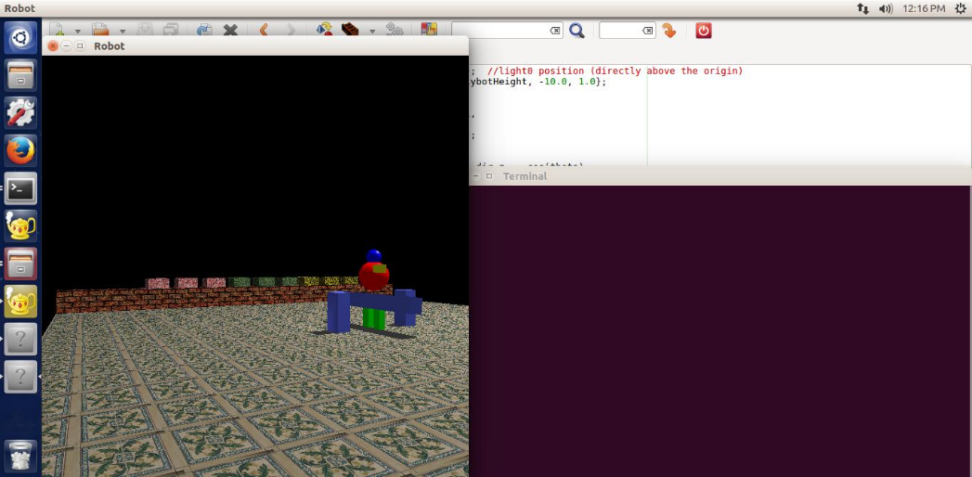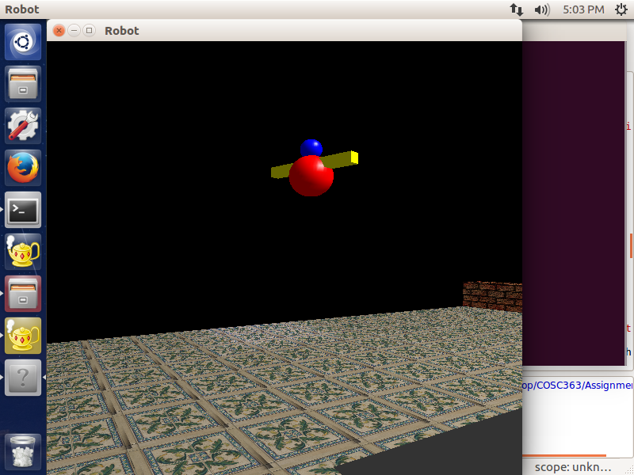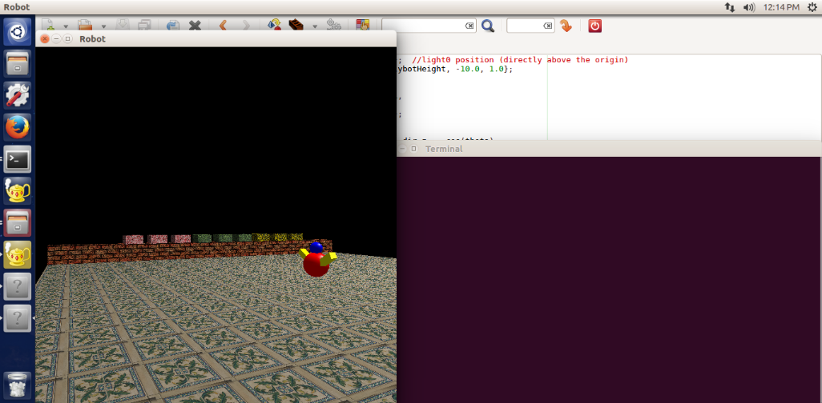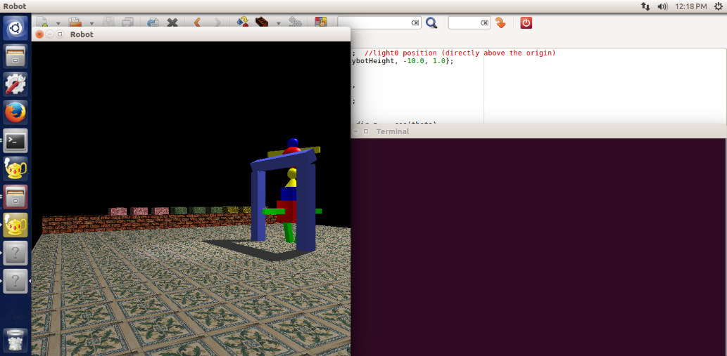Flybot- starts of in the centre of the land, getting ready to fly by changing the angle of its wings (until they are perpendicular to each other) and rotating. As soon as it is ready to fly it generates a bridge type feature which ultimately generates the landbot. Once it gets to its maximum height it travels around the land by circling the land at an anti-clockwise direction, also shining a spotlight in the direction it’s travelling in. It is made up of glut objects (spheres, cubes).

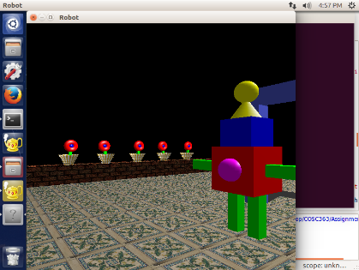

Landbot- Generated by the flybot. Once it is fully generated it travels the outskirts of the land in a clockwise direction by walking. As the landbot reaches a corner it will rotate 90 degrees. The front of the robot is indicated by the magenta sphere on the body. The main function of the landbot is to cut the hedges in half and change the colour flower in the potted plant. Also if the spacebar is hit the landbot will remain stationary, staying in its current position until the spacebar is hit again. It is made up of glut objects (cubes, sphere, cone).

Hedges- They sit on top of a wall. A hedge can be three colours red, green and yellow. The inner most hedge will grow the most as the flybot’s spotlight lands on it. Each hedge will only be cut in half when the landbot gets close enough to the hedges. If the hedge gets too high the pattern will repeat itself using its height, h to be divided by 20 so that the texture will not be stretched out. It is made using GL_QUADS.

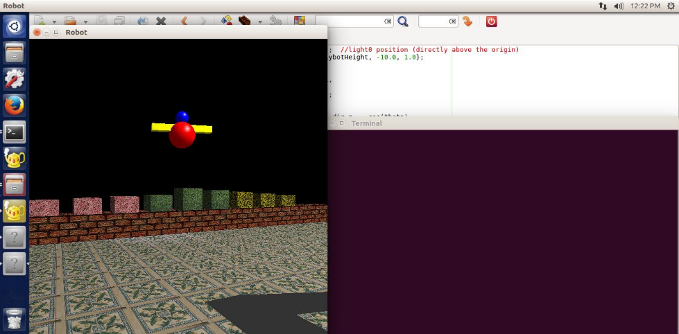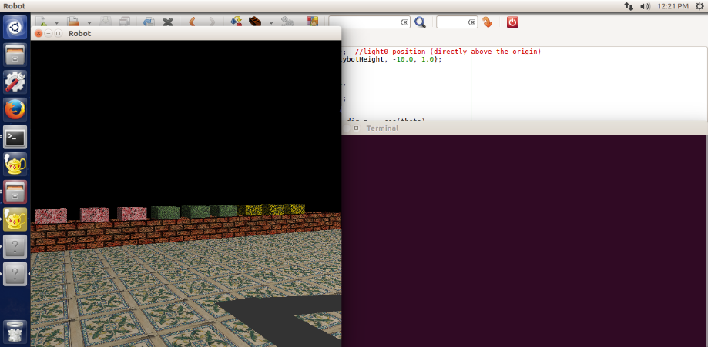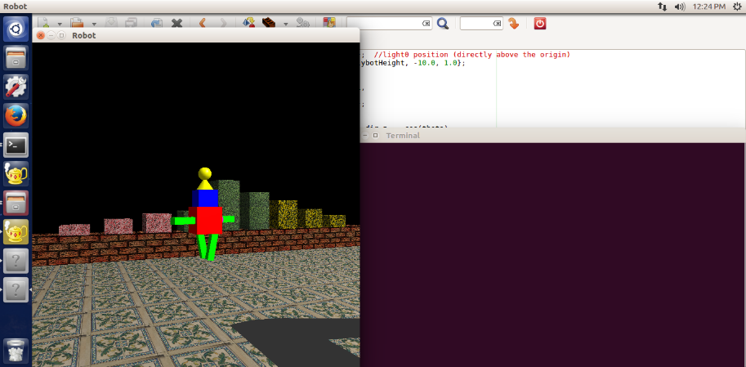

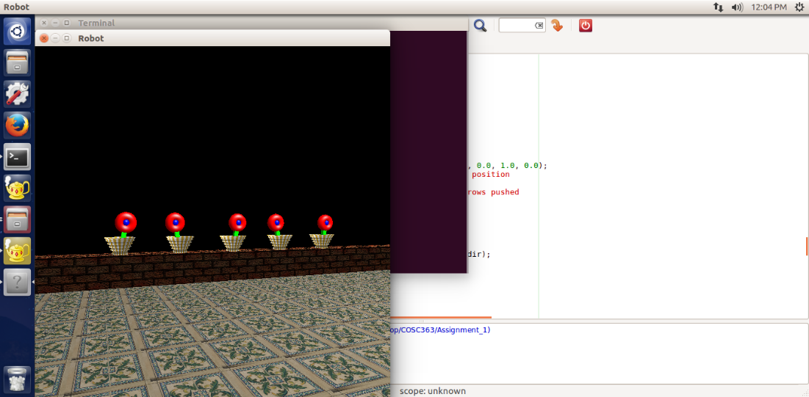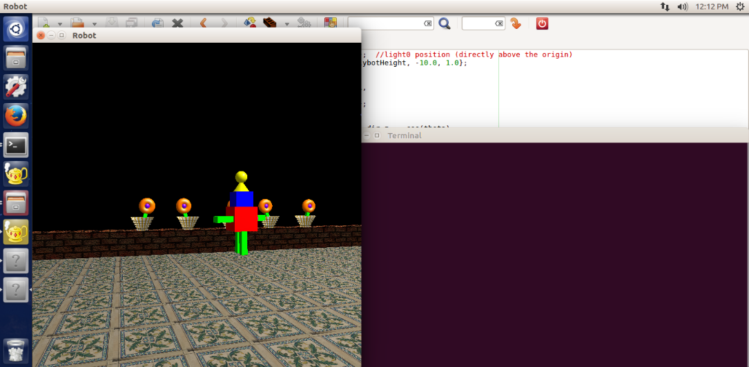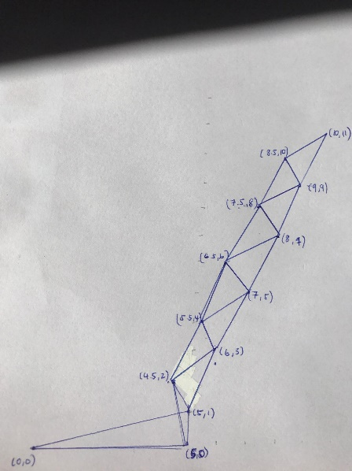Potted plants- The potted plants sit on top of wall. The pot is made based on a simplified version of the vase model in lab 4 in that a triangle strip (shown in figure below) is made and then rotated 36 times at 10 degrees, the colour pattern of the pot is made by alternating the colour of each strip made between white and gold. The flower itself is made with glut objects (torus, sphere, cube). When the landbot is not near the flowers it sways, the next flower sequentially swaying in the opposite direction. When the landbot is near/is in the section of the potted plants the flowers will stop swaying and start to change its colour.

Initial coordinates for triangle strip

vx[N] = {0, 5, 5, 4.5, 6, 5.5, 7, 6.5, 8, 7.5, 9, 8.5, 10};

vy[N] = {0, 0, 1, 2, 3, 4, 5, 6, 7, 8, 9, 10, 11};

Bridge- Generated by the flybot by starting to fly which in turn generates the landbot. When it is fully formed it looks like a bridge/doorway figure with the top bit rotating and its shadow can be fully seen on the floor. I initially wanted to set the shadow’s alpha level to be less than 1, to appear more transparent as the floor is tiled and not set to a solid colour it would have been more realistic to see the tile patterns with the shadow on it. However, the shadow colours kept flickering, shown below so I decided to just leave the alpha value to 1. Made from glut objects (cubes).

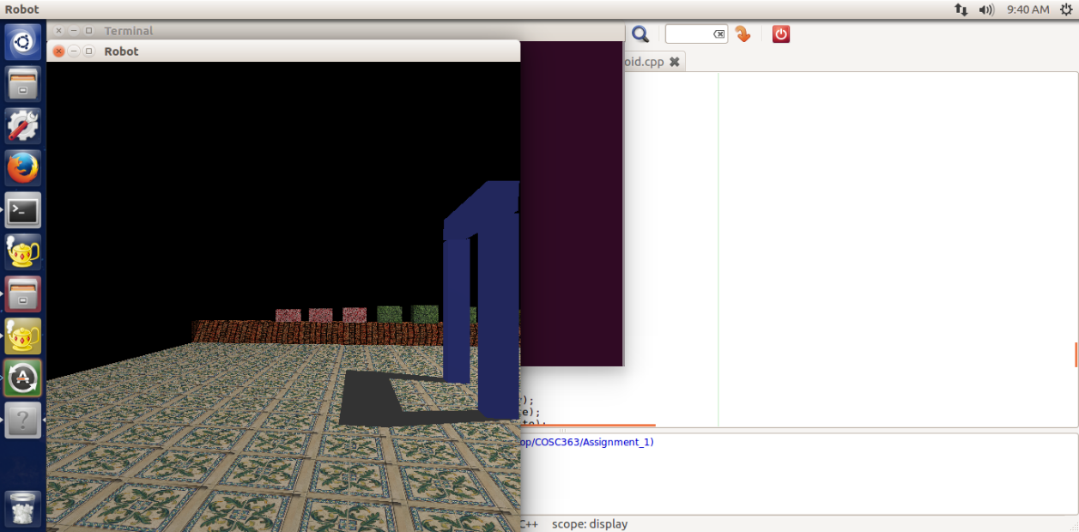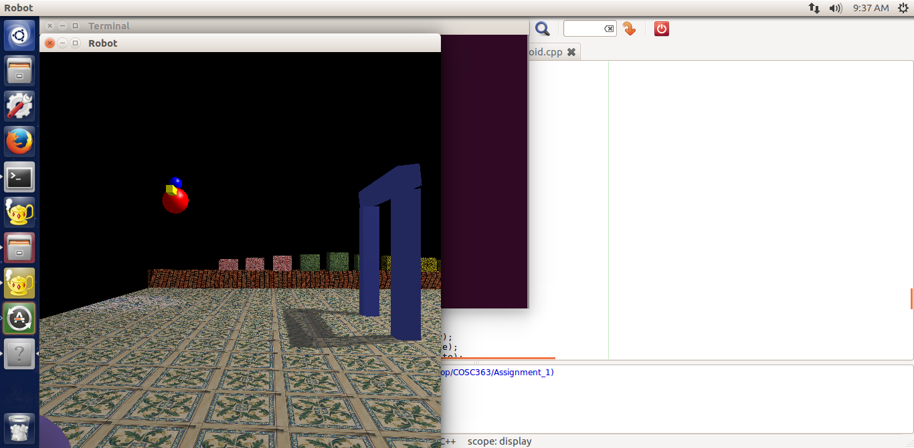

Floor and wall- the floor is 200x200 with each 20x20 section placed with a tile so that the floor is patterned. The wall is 200x20 and is textured with brick which repeats itself across the x-axis. Both are made using GL_QUADS.

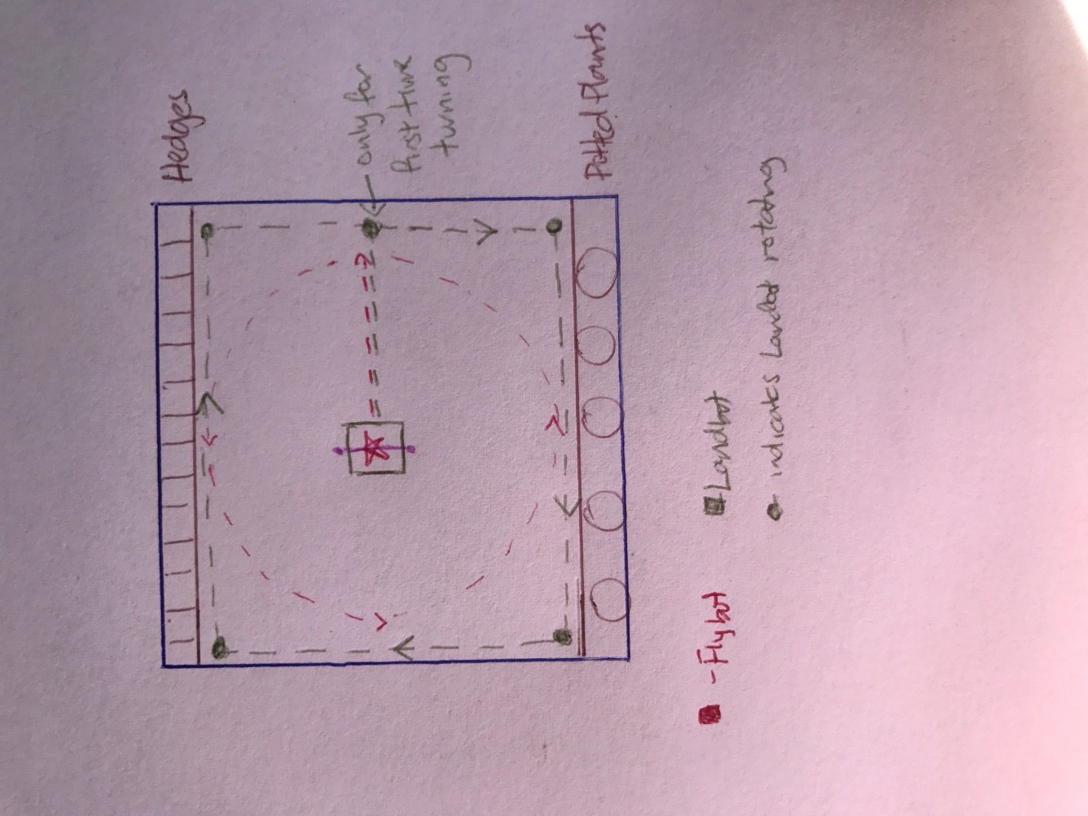**Overview of the scene showing movements of the landbot and flybot**

**Functionalities**

Up arrow – step forward in the scene

Down arrow – step backward in the scene

Left arrow – turn left by 5 degrees (turn in anti-clockwise direction)

Right arrow – turn right by 5 degrees (turn in clockwise direction)

Spacebar – stop/start the landbot from moving toward its current direction

**Resources & References**

**Textures**

Red Hedge- <http://www.textures.com/download/flowerbeds0026/24666>

Green Hedge- <http://www.textures.com/download/hedges0013/8756>

Yellow Hedge- <http://www.textures.com/download/flowerbeds0038/14308>

Wall- Same as the texture of the wall in Lab 5

Floor- <http://www.textures.com/download/tilesornate0116/24342>

loadTGA header file- same as the ones used from labs